**DATE: 2/13/2013  
T0: MARK KOCHANSKI  
FROM: Sohaib Hussain**

**TEAM MEMBERS: Sohaib Hussain, Paul Kwon, Anthony Hopkins, John-Paul Wallway  
SUBJECT: TEAM IOBYTES STATUS REPORT: 2/20-2/27**

**PROJECT STATUS SUMMARY** Percent Complete: 30% (roughly 30 hours of 101 total completed)

The PM Meeting this week covered what we completed in the by the end of this current sprint cycle. Questions have been submitted to the design team. We have created a portfolio that is *not* final, and will improve over the course of the project. This cycle, we rounded up whatever important use cases we found and put them in with our current artifacts. An impromptu, but completed goal was to improve communication with other teams.

**WORK PLANNED FOR LAST WEEK**

* Complete portfolio with all web pages
* Adjust website design based off the results of the survey
* Come up with new questions for the next survey
* Have portfolio of artifacts with final designs of the 6 web pages
* Assemble use cases for website design (.5 hour of work per week)
* Assemble use diagrams for website design (.5 hour of work per week)

**WORK COMPLETED LAST WEEK – Encompassing Items from Backlog**

* Adjusted website designs (still in progress – from backlog)
* Came up with new questions for next survey
* Completed portfolio (version 2 – from backlog)
* Assembled use case scenarios (not complete, but finished what we aimed to set out and accomplish)

**WORK PLANNED FOR NEXT WEEK AND BEYOND**

* [Beyond] implement working prototype for website (estimated 5 hours of work per week)
* [Beyond] implement features from backlog (estimated 10 hours of work per week)
* [Beyond] run prototype testing (estimated 5 hours of work per week)
* [Beyond] implement changes from testing (estimated 10 hours of work per week)
* [Beyond] finalize changes, run acceptance testing (estimated 15 hours of work per week)

**IMMEDIATE TASKS**

|  |  |  |  |  |  |
| --- | --- | --- | --- | --- | --- |
| Tasks | Planned | Forecasted | Actual | Status | Cost (in hours), for this week |
| Complete portfolio (version 3) | (2/13/13) | (2/20/13) | N/A | Begun | 5 hours |
| Complete Use cases | (2/20/13) | (2/28/13) | 2/27/2013 | Begun | 2 hour |
| Come up with new questions for next survey | (2/10/13) | (2/20/13) | N/A | Begun | .5 hour |

Resources to be used in tasks: surveys, use case modeling software (possibly simple graphical image manipulation software), computers for communication, manpower (team BetaBytes).

**PROJECT BACKLOG – Remove when ready to put into work to be completed per week lists**

DESIGN – 1 is highest priority

1. Send out final or incremental portfolios
2. Finalize mockups for UI
3. Finalize all use cases
4. Create activity diagrams

FUNCTIONALITY – Not prioritized

* Implement database client library
* Implement database interactions (from Database team)
  + Implement peer review updating feature
  + Implement new class creation tool (instructor)
  + Implement student score reviewing query
  + Implement students in group query
  + Implement students in team query
* Implement app download feature, for mobile
  + Add to mockups
  + Implement actual download feature
* Update UIs to include user functionality explanations
* Implement iOS/Android compatibility views
* Implement site plug-in with Canvas and other LMS
* Implement standalone site for unhindered usage
* Implement custom criteria creation tool
* Implement and ensure compatibility with most known and most used browsers
  + Chrome
  + Safari
  + Opera
  + IE (10, and the rest)
  + Firefox
* Implement Database update functionality

**ARTIFACTS**

## Versions 1.0 of Artifacts

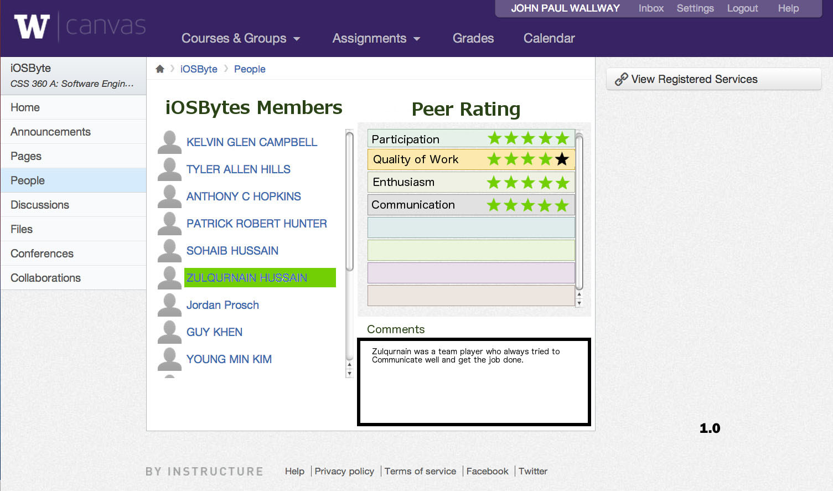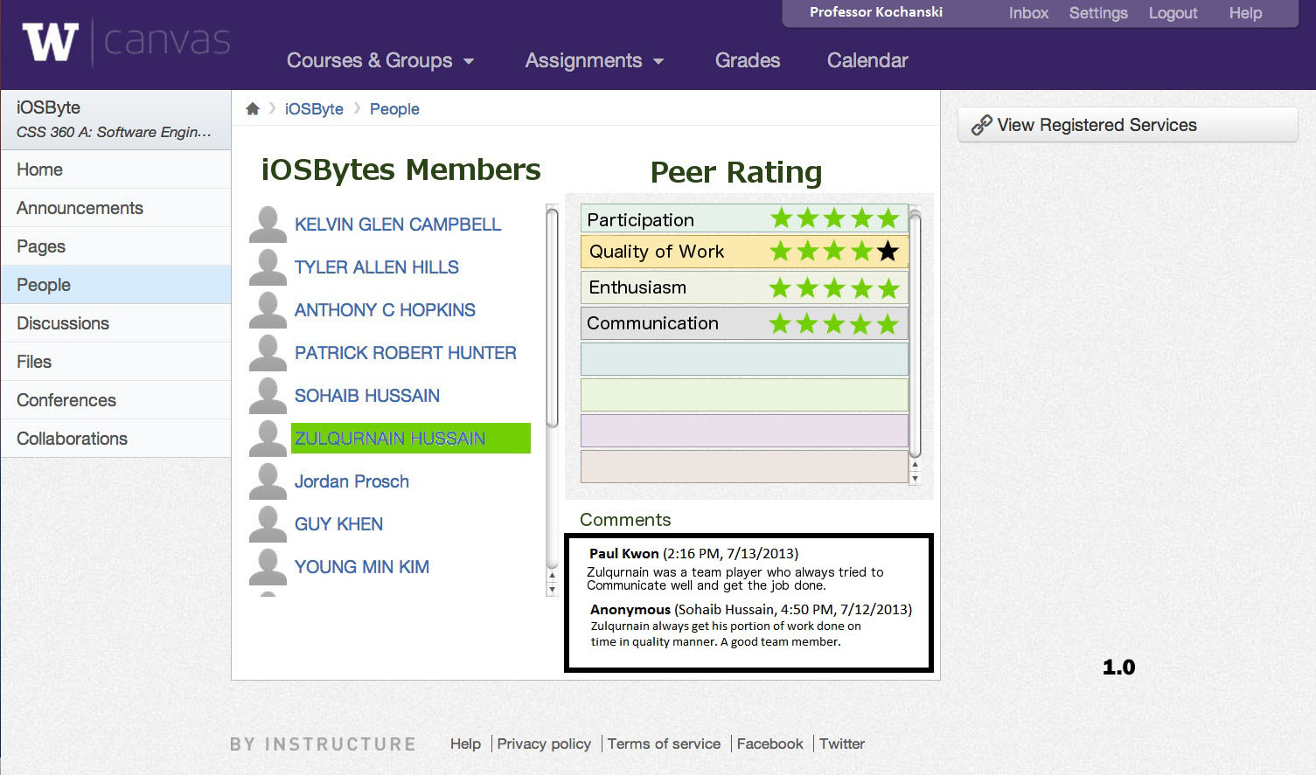  
The picture above is an instructor view of the peer review page, version 1.0. The instructor can see each student’s work (via communication with the database, in construction and maintenance by the database team) for the peer rating retrievals, as well as the comments.

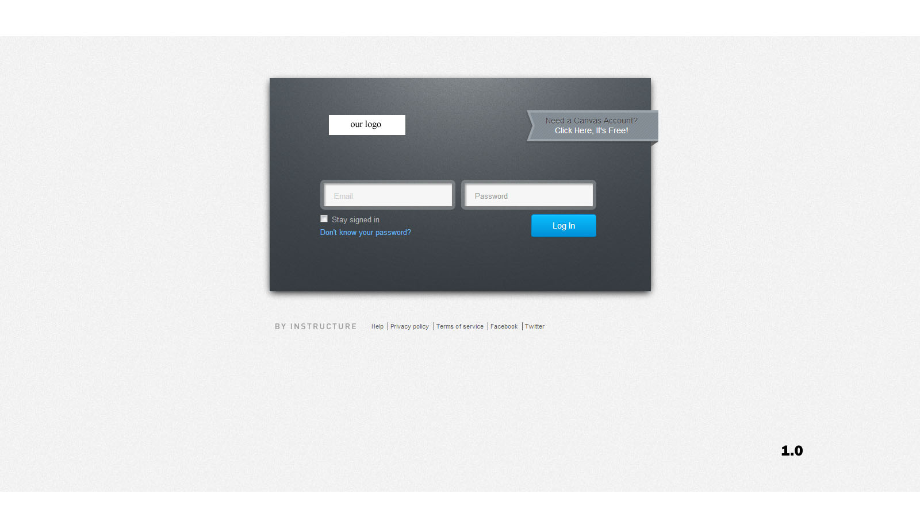The picture above is a student view of other team members, version 1.0. The main difference between this and the previous picture is that you can only view your own comments, rather than everyone’s. Again, by clicking on a name, the website fetches information via the database (courtesy the database team).

Above is version 1.0 of the login page. It would use Canvas’ login, if that is what most instructors prefer. From here, you can login to your generic instructor/student homepage.

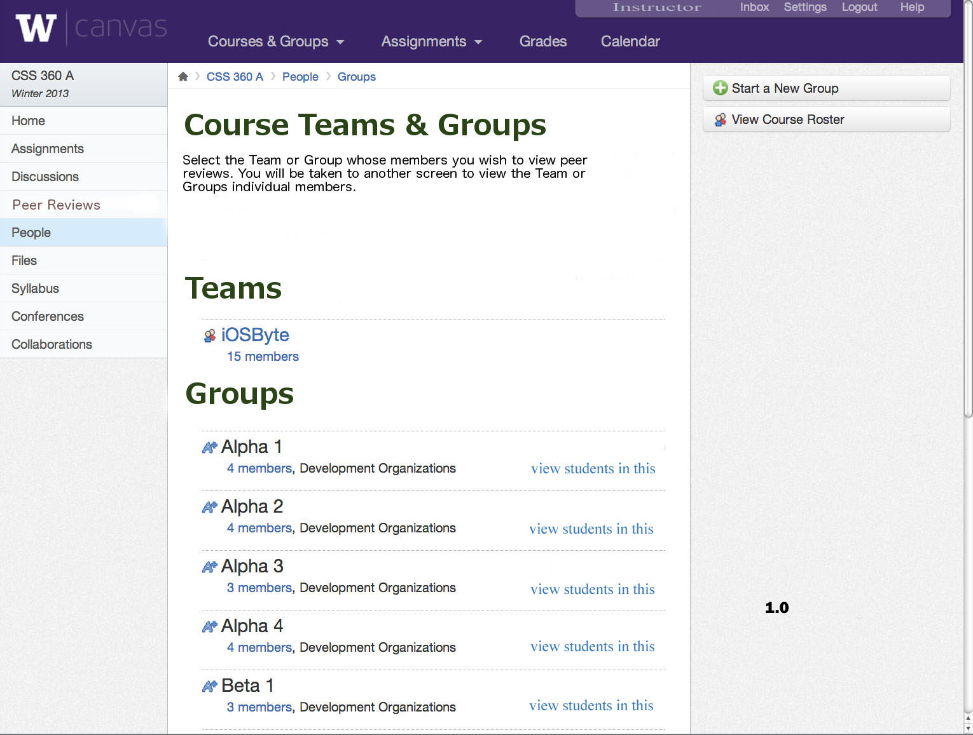

This snapshot shows the generic instructor homepage for a specific class (version 1.0). From here, the instructor can click on and view any team, and any of its members, including all of their reviews and ratings, complete with who wrote them.

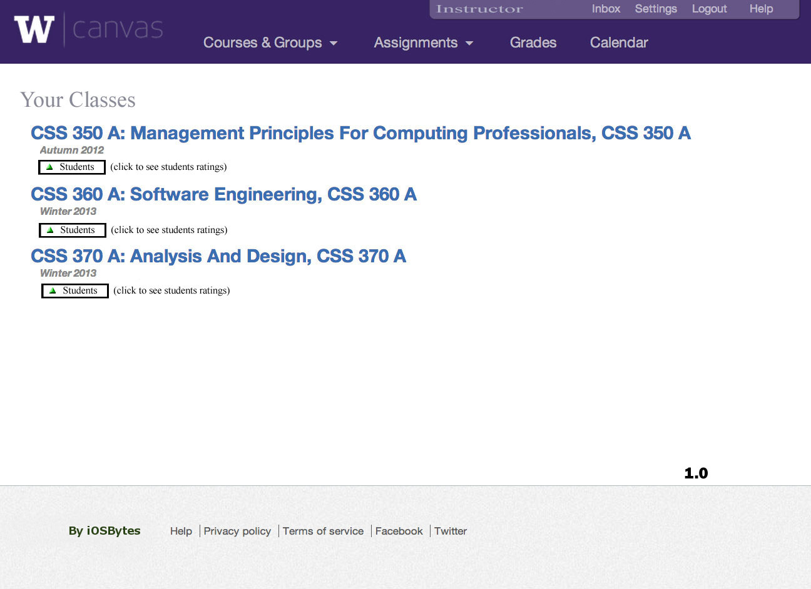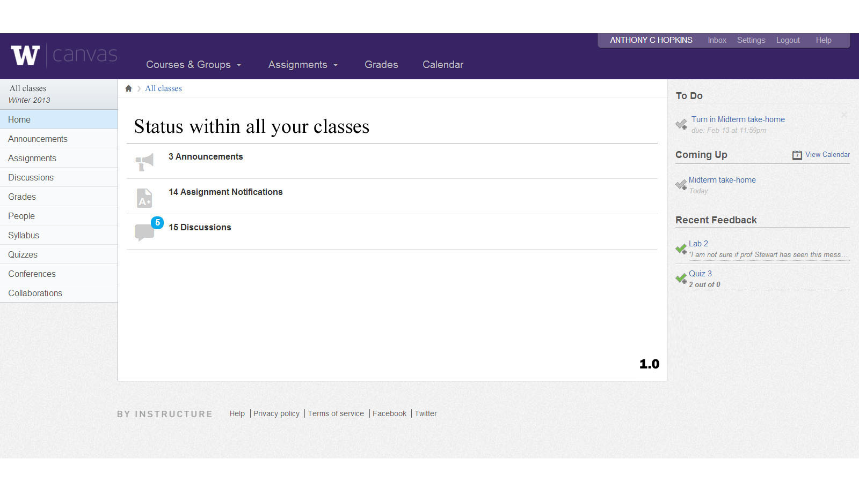Above is a generic student page, version 1.0. From here, you can navigate your course via the sidebar on the left, or the options in the middle.

Generic instructor homepage (version 1.0). From here, an instructor can immediately navigate to students, or they can navigate to any specific course from here.

# C:\Users\Ifsozuan\Desktop\Version 1 design templates 360\Choosing grading criteria.jpg

Generic instructor peer review creation page (version 1.0). From here, the instructor can create his own custom grading criteria (the list box in the middle of the page with participation, quality of work, etc). He can still view the students in the group/class/company from here (the list of hotlinked names on the left side), and navigate to other parts of his site (the nav bar on the left).

# Updated Versions

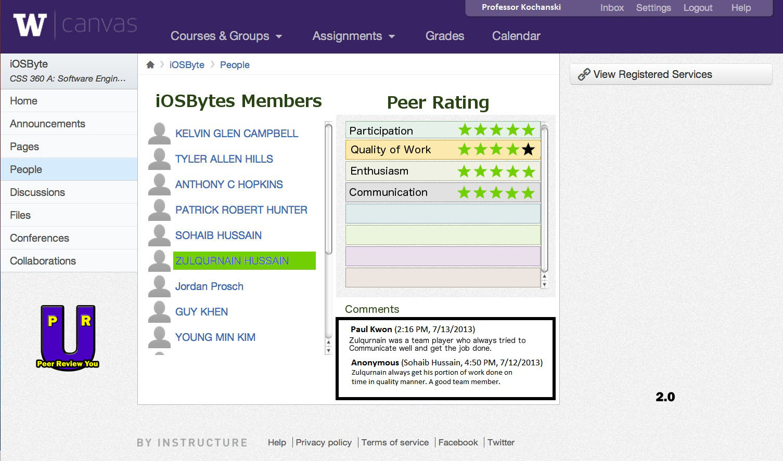Professor page for a team (version 2.0). Difference between 1.0 and 2.0: added company logo to bottom left.

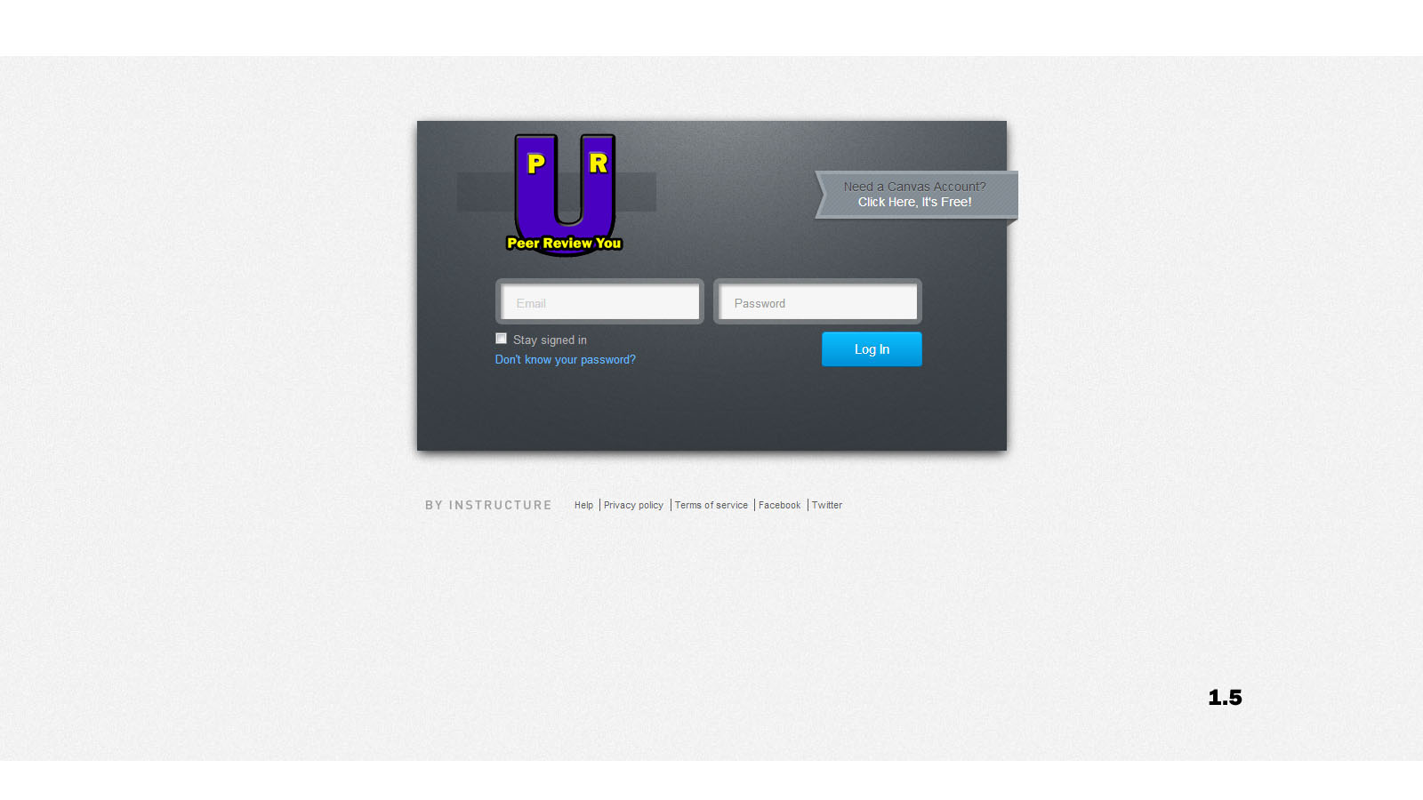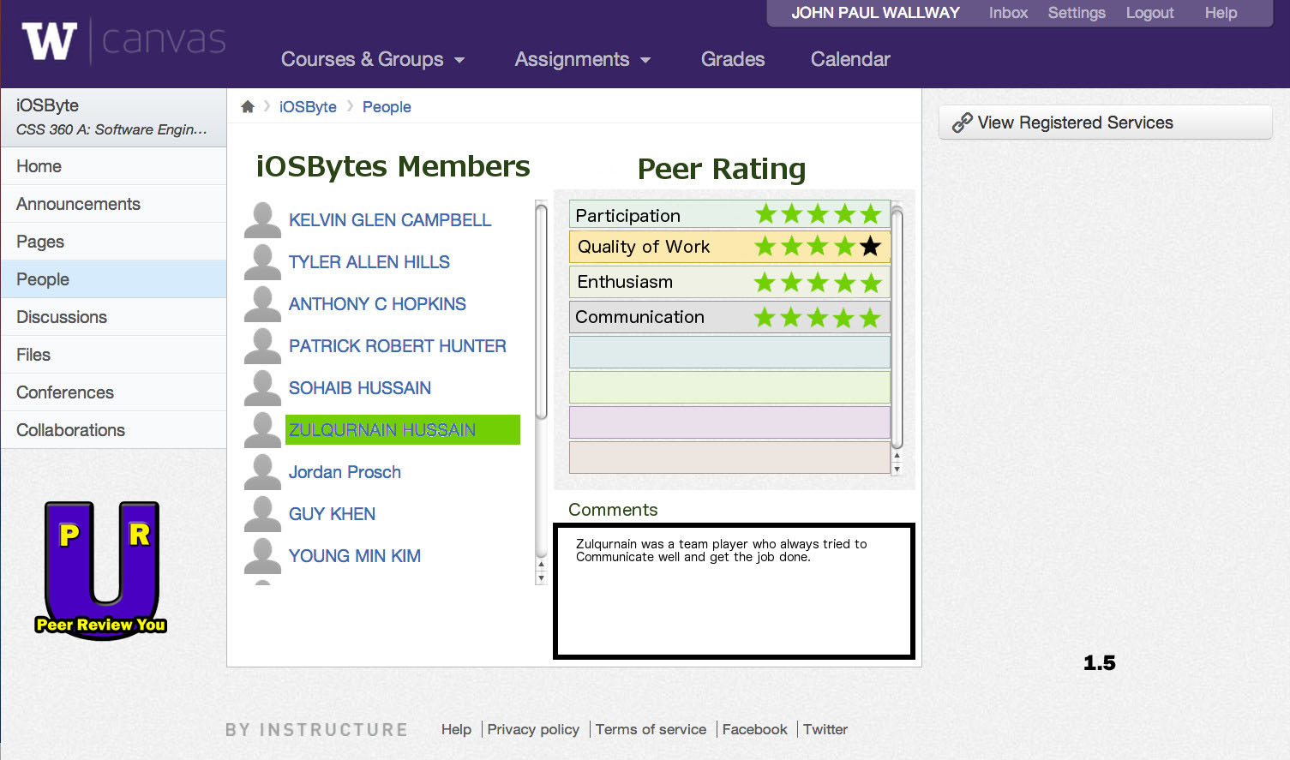Student team page (version 1.5). Differences between 1.0 and 1.5: added company logo to bottom left.

Generic login page (version 1.5). Differences between 1.0 and 1.5: added company logo to top left.

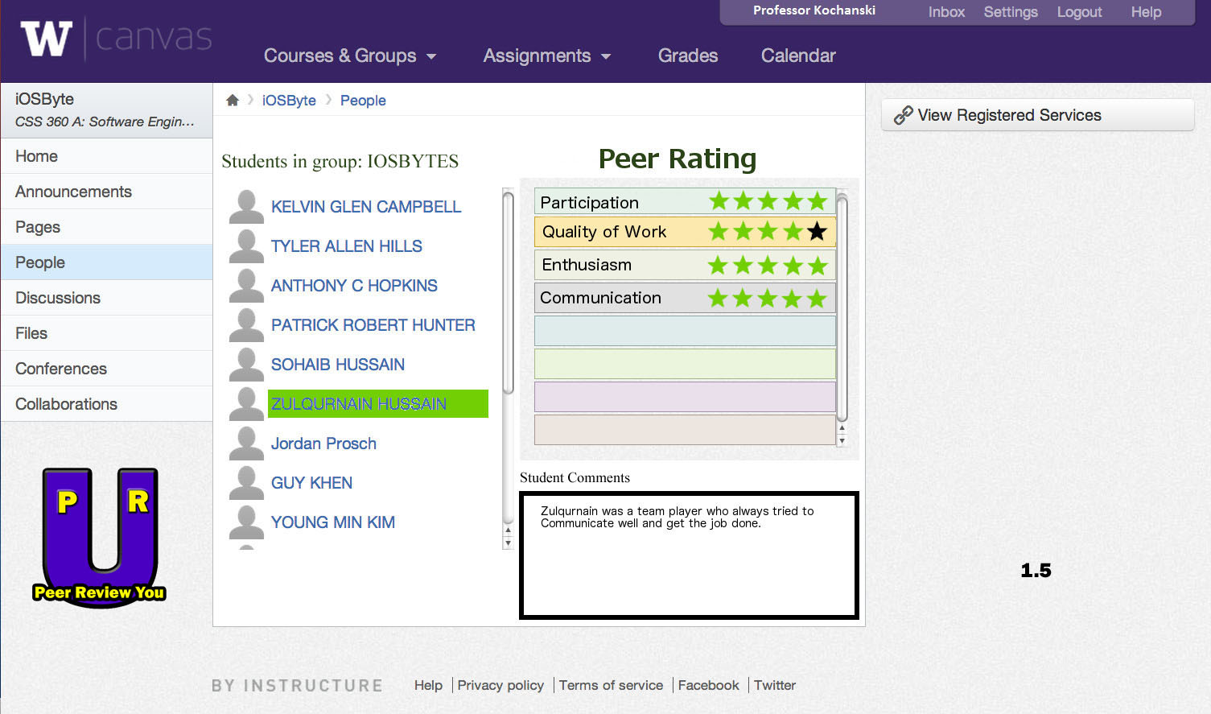

Generic instructor page (version 1.5). Differences between 1.0 and 1.5: added company logo to bottom left.

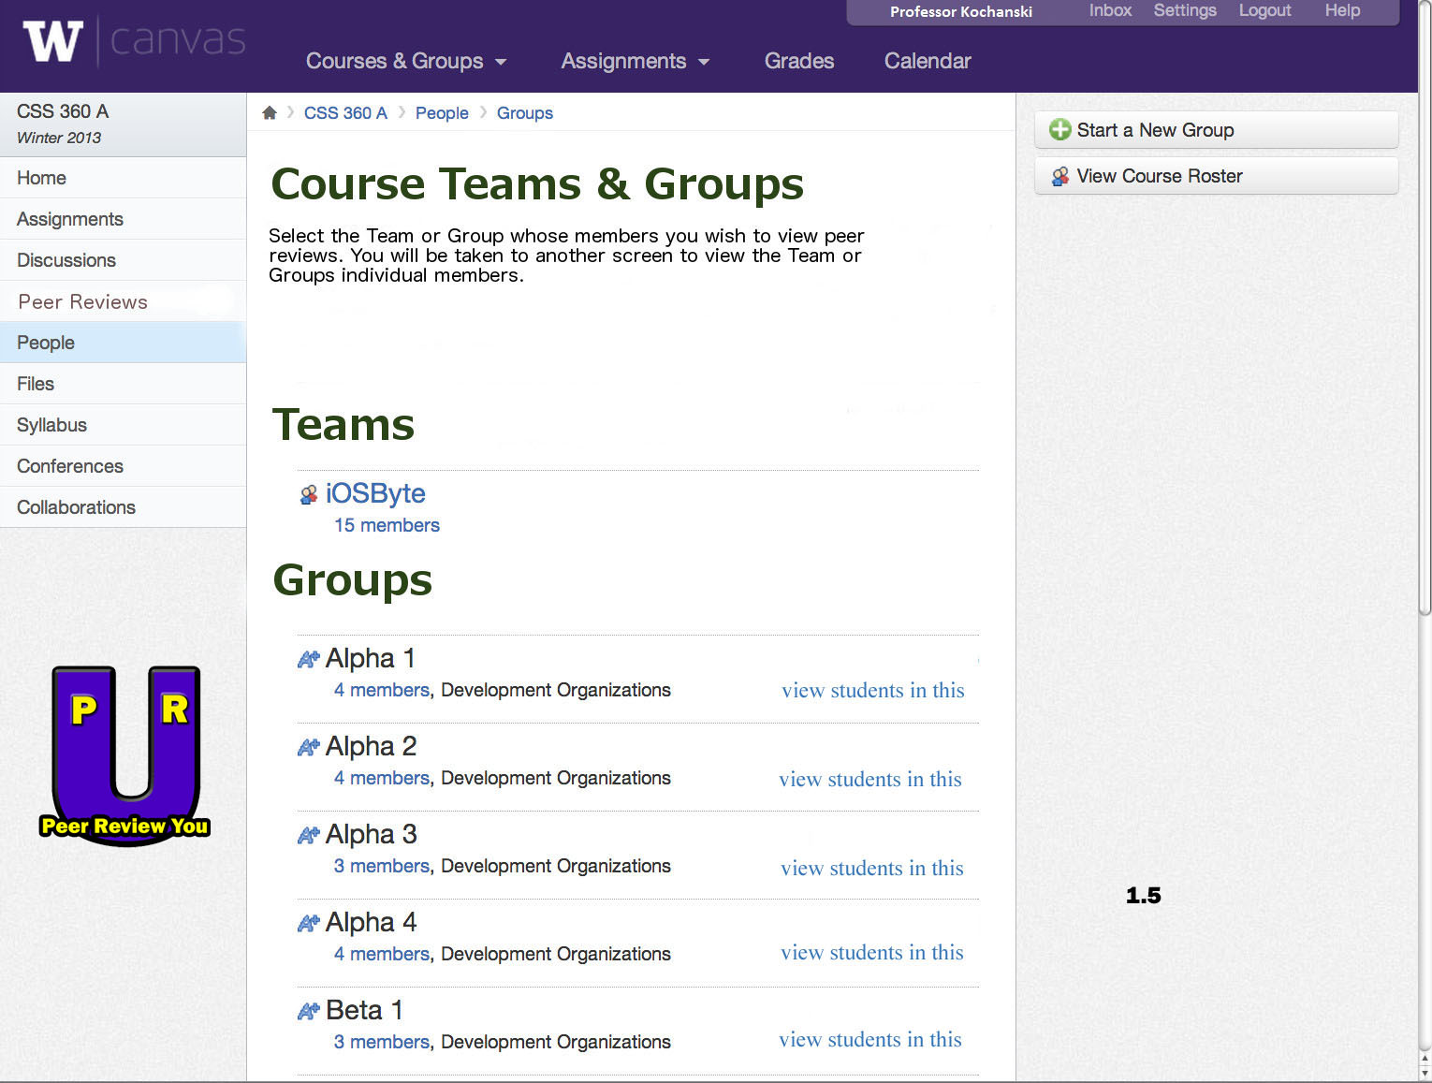

Generic instructor course page for peer reviewing (version 1.5). Differences between 1.0 and 1.5: added logo to bottom left.

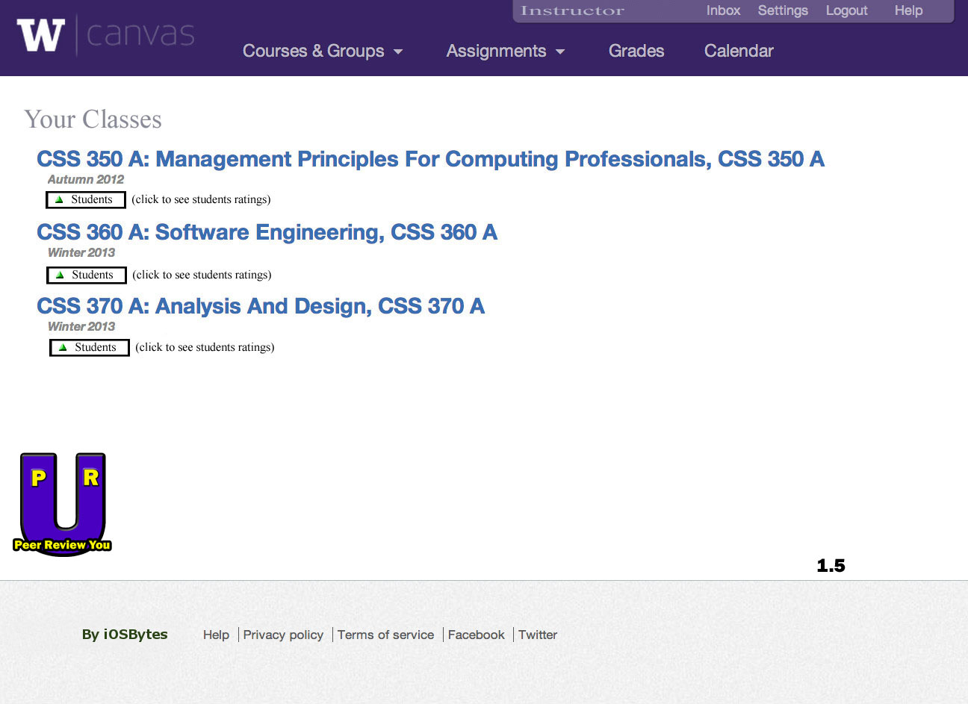Generic instructor homepage (version 1.5). Differences between 1.0 and 1.5: added logo to bottom left.

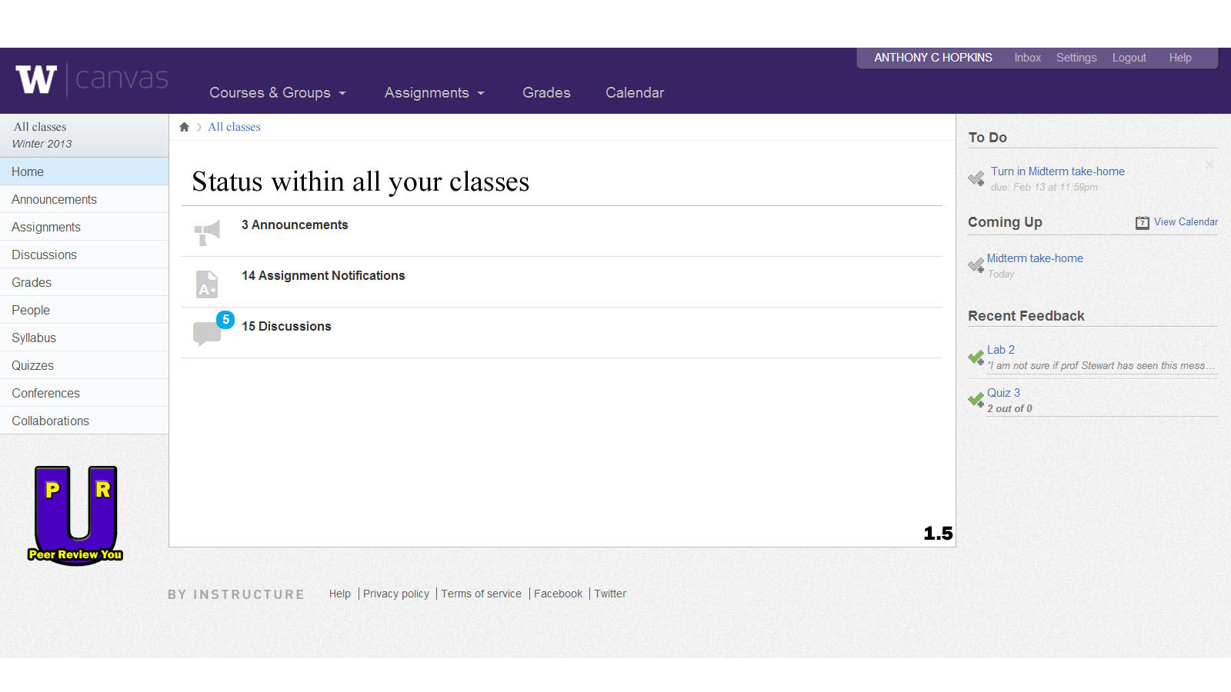

Generic student homepage (version 1.5). Differences between 1.0 and 1.5: added logo to bottom left.



Generic student homepage (version 1.5). Differences between 1.0 and 1.5: added company logo.

**USE CASES**

**LIST OF CASES CURRENTLY CREATED**

Instructor creates Peer Review Form

Student rates a peer

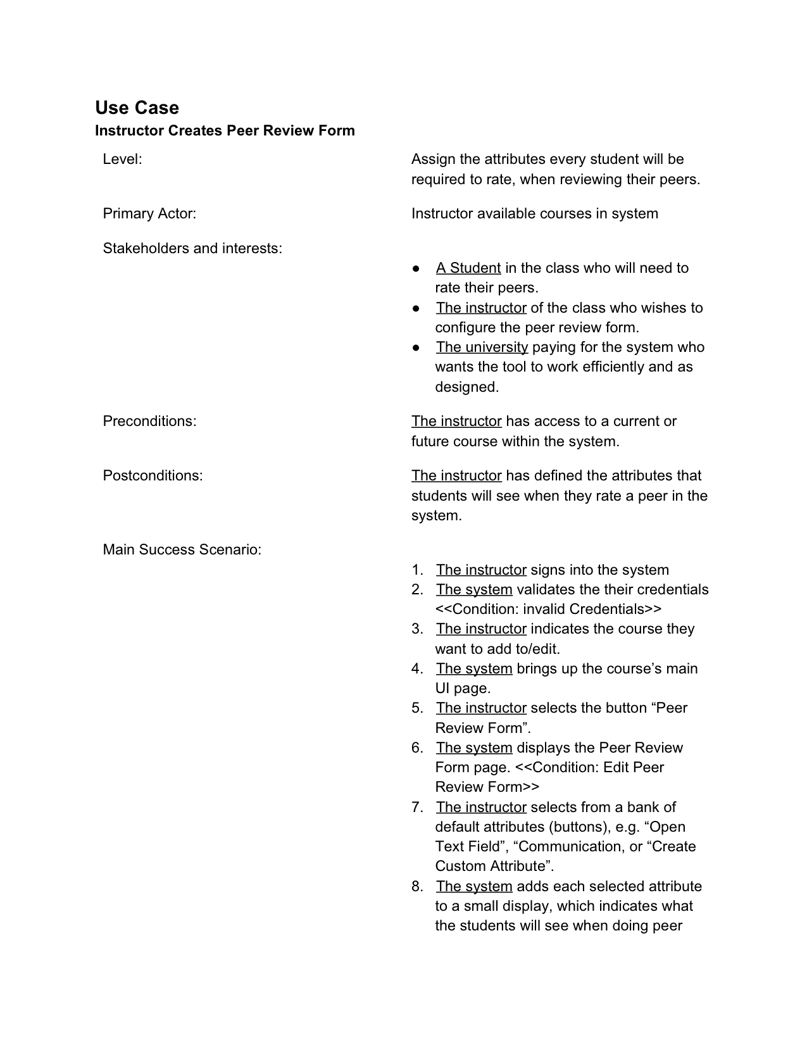

**Use Case**

Student uses website to rate peers

* **Level:** Assigns values to other students based off the rating system and rating options available
* **Primary Actor:** Student utilizing the rating system
* **Stakeholders and Interests**:
  + A student utilizing the system
  + An instructor wishing to see his/her student’s ratings
  + The university wishing to use the system via payment
* **Preconditions:** A student has access to the website
* **Postconditions:** A student knows who they wants to rate, and how they wants to rate them
* **Main Success Scenario:**
  1. The student signs in to the system
  2. The system validates credentials of student
  3. The student navigates to the peer review system page (in LMS or separate site)
  4. The system updates the page the student has gone to by communication to the database
  5. The student selects a team member to peer review
  6. The student rates the peer with the given criteria(s)
  7. The system relays that information to the database, updating the current info on the students